EMPOWERING KWAHU EAST FOR INTEGRATED SOCIAL SERVICES (ISS)!
On February 3rd, 2026, the Kwahu East Municipal Assembly (Department of Social Welfare & Community Development) took a significant step toward enhancing Child Protection and Social Welfare. The Regional Social Welfare team led an intensive training workshop designed to orient stakeholders on Case Management for Integrated Social Services (ISS).
Our Goal
The workshop aimed to streamline the Integrated Social Service Delivery System. By orienting key stakeholders on holistic service mechanisms, this initiative ensures better survival outcomes for our Communities and drives Municipal development.
Key Highlights from the Workshop:
- A New Milestone: Kwahu East is one of the newest districts in the Eastern Region to benefit from the ISS program, making this training essential for effective implementation.
- Strategic Vision: Coordinating Director Mr. Kwadwo Gyamfi welcomed the initiative, urging stakeholders to embrace the opportunity to make child protection a reality.
- Expert Guidance: Regional Director Mr. Isaac Koramoah Asante provided deep insights into case management, including guiding principles, risk categorization, and child protection pathways.
- Legal Clarity: The training established a clear distinction between reporting criminal cases to DOVVSU and non-criminal cases to the Department of Social Welfare & Community Development (DSWCD), while addressing the critical issue of child trafficking.
- Diverse Collaboration: Representatives from Ghana Health and Education Services, DOVVSU, Religious Groups, NPOs, and Local Assembly Members joined forces to discuss local challenges like early marriage and adolescent pregnancy.
Participants expressed great enthusiasm, noting that securing a better future for our children is the key to lasting development for Kwahu East and Ghana at large. “We are committed to becoming the top district in the country for the Integrated Social Service delivery”! participants exclaimed.
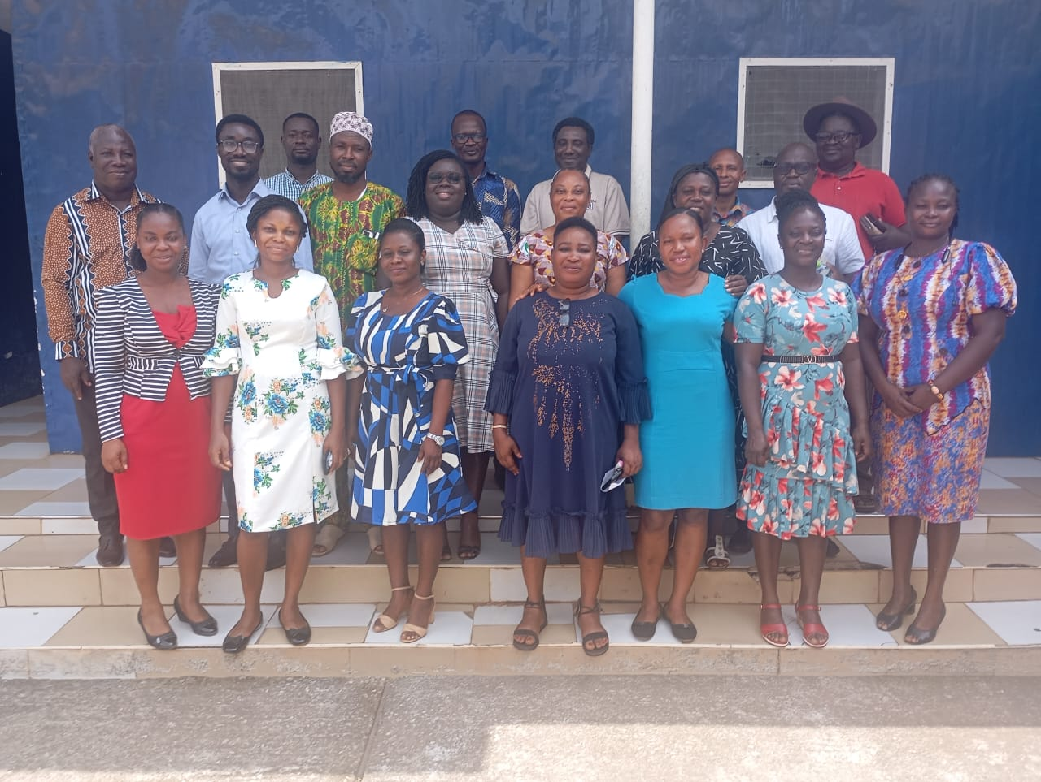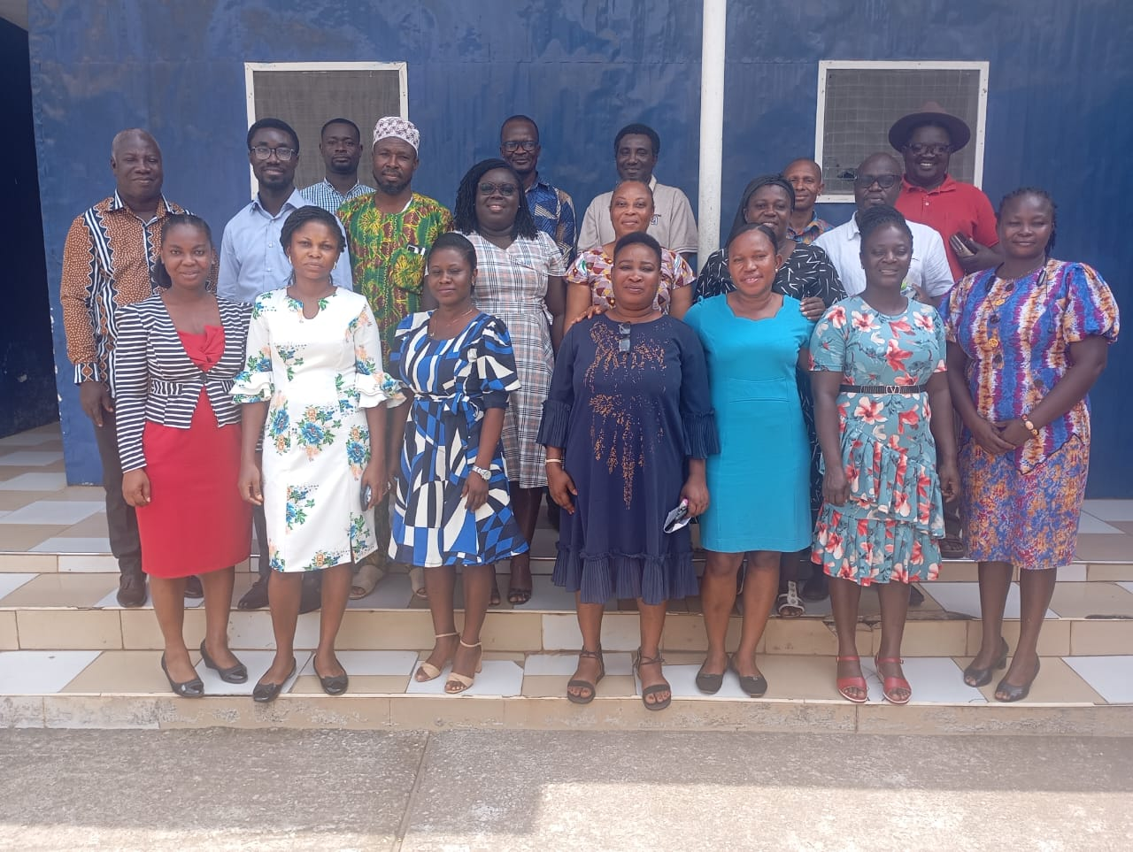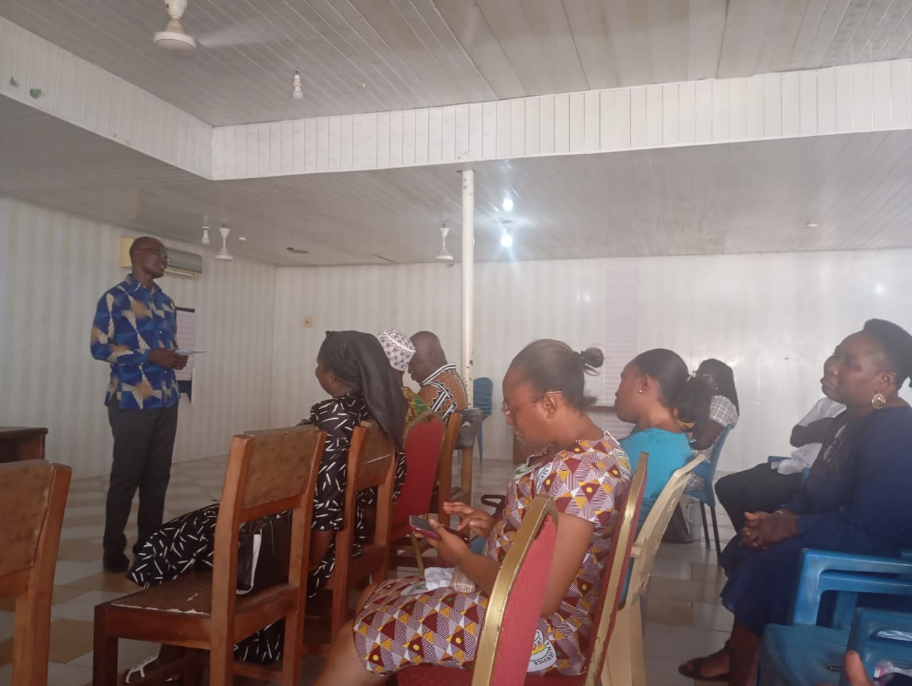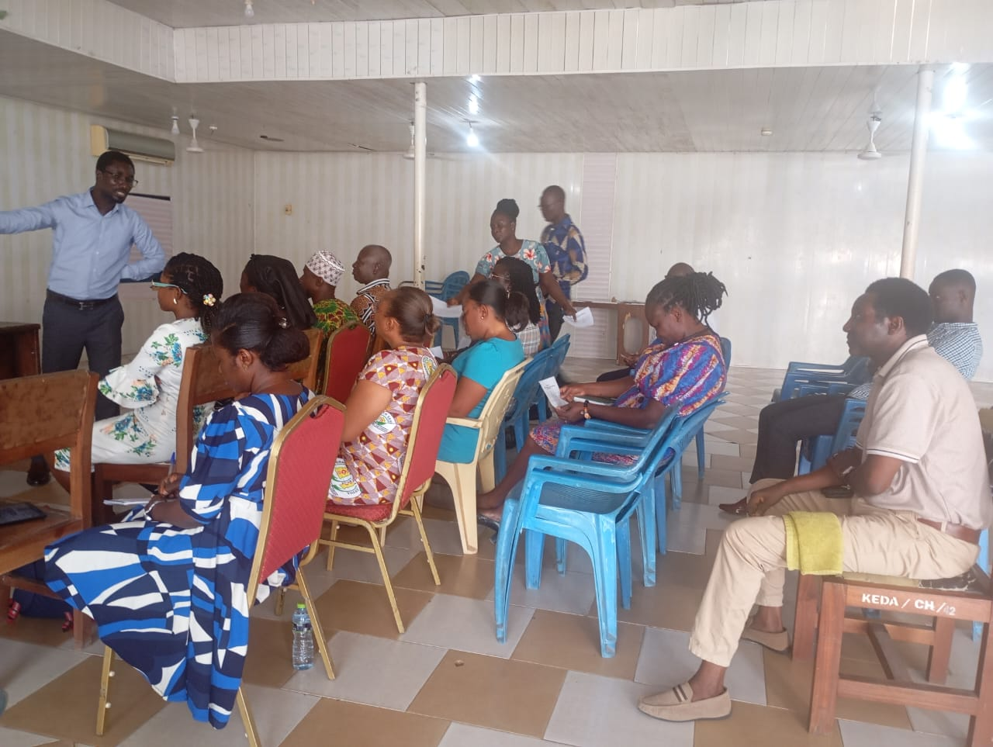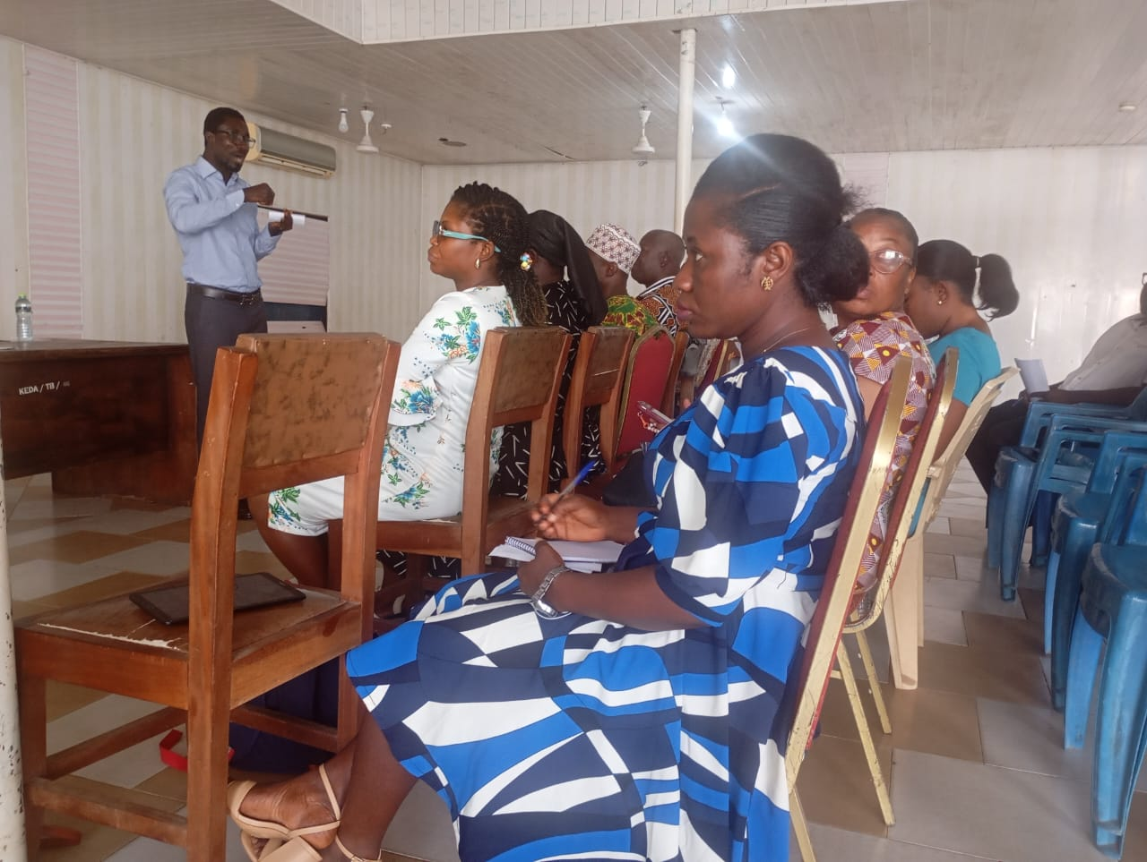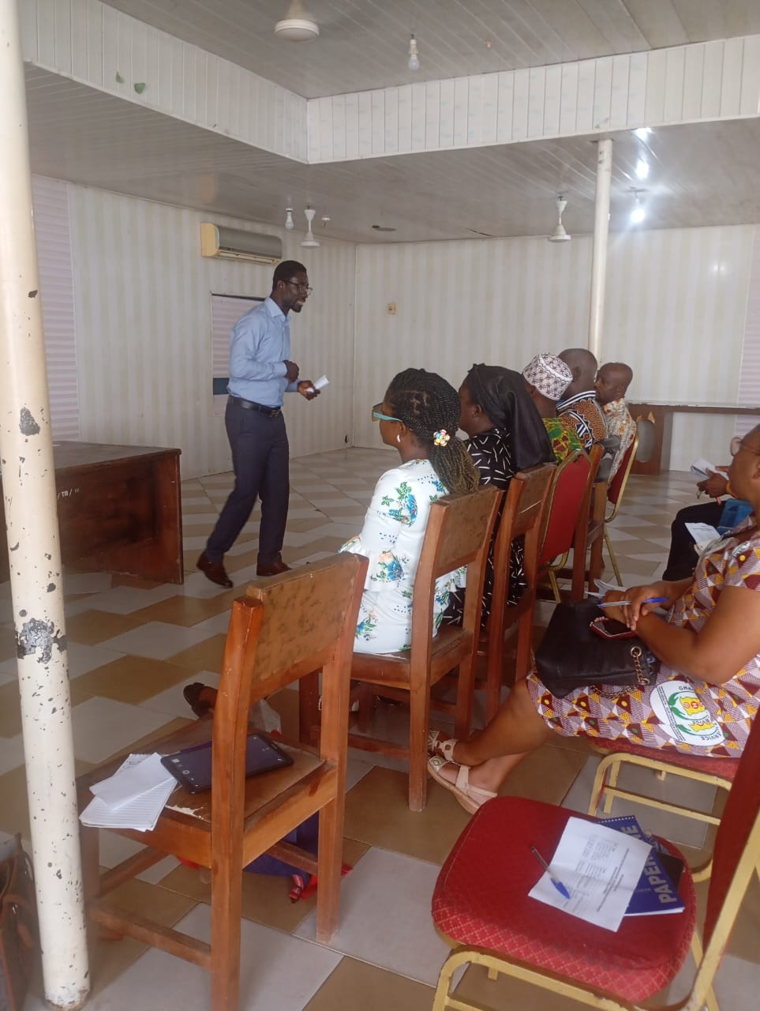
#KwahuEast#SocialWelfare#ChildProtection#IntegratedSocialServices#CommunityDevelopment #Ghana

