WASSCE Monitoring
The West African Senior High School Examinations for the year 2024 commenced on 5th August to 20th September, 2024.
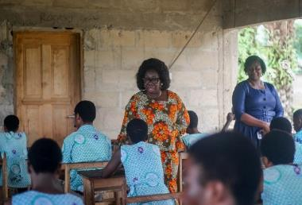
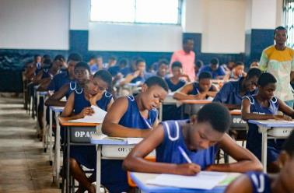
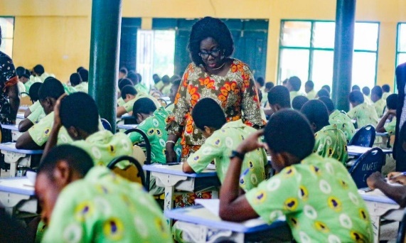
The Regional Director led two (2) teams to monitor the conduct of the examinations. The teams visited selected centres across the region, Schools monitored include Akroso SHS, Salvation Army SHS, Kade SHS, Asuom SHS, Apesua Community Day SHS, Krobo Girls SHS, Nsawam SHS, New Juaben SHS, Oti Boateng SHS, Pope John SHS, Koforidua SHTS, Pentecost SHS and SDA SHS, Asokore.
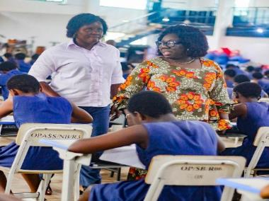
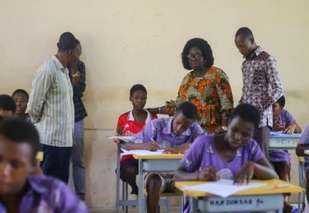

My First Day at School
Basic Schools reopened on Tuesday, 10th September, 2024 and officers from the regional Directorate joined with the Municipal Chief Executive for New Juaben South, Hon Isaac Apau-Gyasi and the Municipal Director of Education for New Juaben South, Mr Haruna Mustapha Appiah and his team visited some schools in the municipality to observe ‘My First Day at School’ for new entrants.
The exercise was to welcome new entrants into school. Some of the schools visited were Agavenya R/C Basic, Korley Nkwanta Good Shepherd Anglican Basic, Trom M/A Basic Densuano M/A Basic and Nana Oware Agyapong M/A Basic, all in the New Juaben South Municipal.
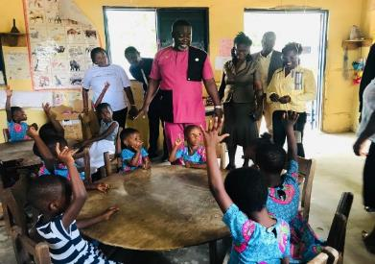
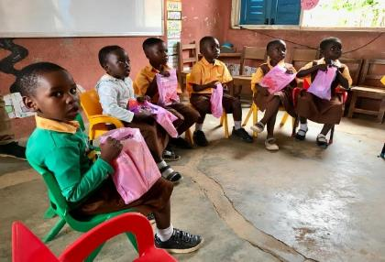
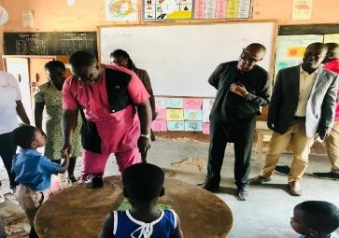
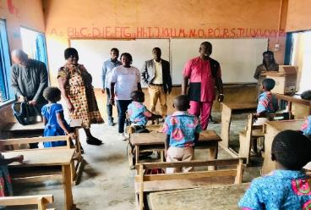
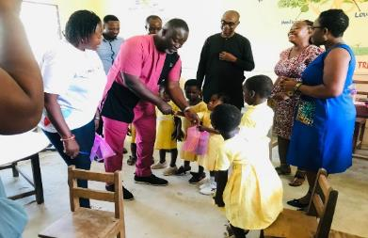
CULTURAL EDUCATION UNIT;
Regional ONGA Cook Art Competition; In order to select two schools to represent the Eastern Region during the GES – Zonal ONGA Cook Art Competition 2024, the 6th edition of the Regional ONGA Cook Art Competition was held at Aburi Girls’ Senior High School on 15th March, 2024. It consisted of six (6) selected Schools.
At the end of the competition, the following results were recorded; 1st Ghana Senior High School, 2nd Aburi Girls’ Senior High School, 3rd St. Stephen’s P.S.H.T.S., 4th Krobo Girls’ S.H.S., 5th Adukrom P.S.H.T.S., and 6th Nkawkaw S.H.S. Ghana S.H.S. and Aburi Girls’ S.H.S. to represent the Region during the Zonal Competition at a later date.
Zonal Onga Cook Art Competition 2024.; Ghana Senior High School, Koforidua and Aburi Girls’ Senior High school represented the region at the Zonal ONGA Cook Art Competition 2024. The event was held at the Labone Senior High School from 19th- 22nd May, 2024. Ghana Senior High School, managed to qualify from their group to the grand finale after defeating schools like Tamale SHS, Yaa Asantewa SHS, Ekumfi Ameyaw SHS, and Jamiat Islamic Girls’ SHS. Aburi Girls’ SHS on the other hand could not make it to the final.
At the grand finale of the GES ONGA Cook Art Competition held at the same venue, Labone Senior High School from 29th – 31st May, 2024, Ghana Senior High School, Koforidua placed third (3rd). St. Louis Senior High School and Wesley Girls’ Senior High School placed first and second respectively. Adventist Senior High School, Kumasi also placed fourth.
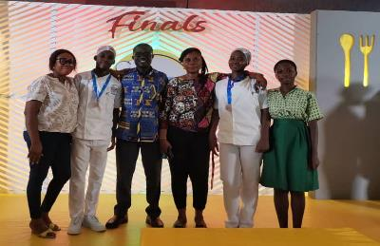
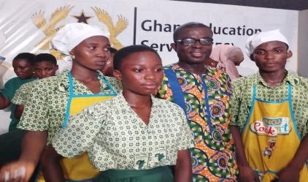
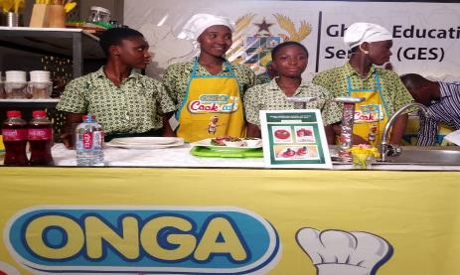
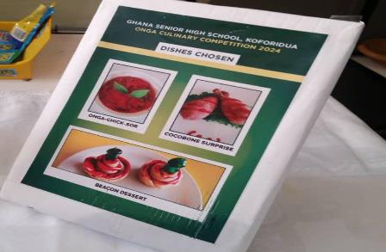
STEM ACTIVITIES:
Regional STMIE Camp Held at The Presbyterian Women’s College of Education, Aburi From 3rd To 6th January, 2024
Four hundred and thirty (430) Junior High Learners participated in the 2023 Regional STMIE camp comprising of 222 girls and 208 boys from 14 Districts/Municipals in the Eastern Region. The 3-days camping was full of scheduled activities on practical Science and Math lessons and test, health and social talk, excursion, project presentation and exhibition, mentorship and was climax with a grand durbar.
The Regional STMIE Camp was aimed at fostering collaboration and friendship and also popularize STEM Education among learners.
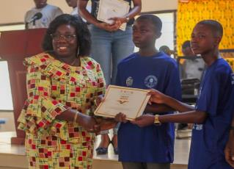
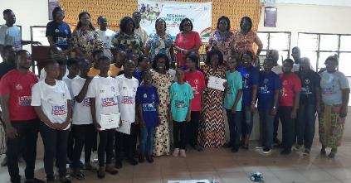
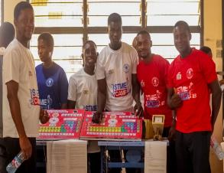
Girls Stem by KOICA Project: Monitoring of KOICA Activities in Five Project Districts
As part of the Regional Level activities for the Girls STEM by KOICA Project, the Regional Level monitoring of KOICA activities in project districts was conducted. The monitoring exercise was meant to evaluate and provide support on activities on-going in project districts and schools. The project districts are: Akuapem South Municipal, Abuakwa North Municipal, Upper Manya Krobo District, New Juaben Municipal and Birim Central Municipal.
Girls STEM by KOICA Project, the monitoring of Organized Teacher Learning Circle (TLC) at the District and Cluster Levels took place from Monday, 9th to Friday, 13th September, 2024. The monitoring was meant to provide support to each project District to ensure the success of the exercise. TLC plays an important role in the Girls STEM by KOICA Project and Teachers, Headteachers and SISOs need to meet plan for topics to be taught during the TLC sessions.
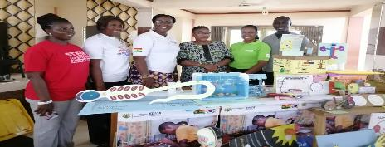
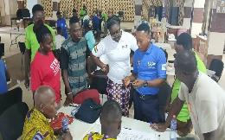
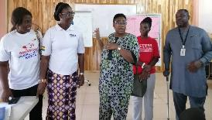
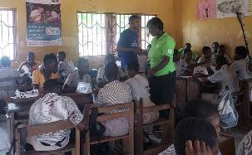
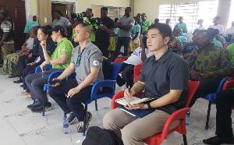
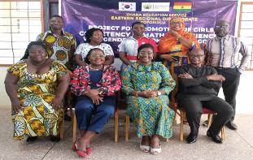
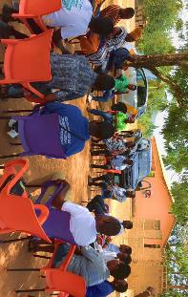

Report On the Celebration of International Day for Women and Girls in Science On 11th February, 2024
The Science Education Unit (National STEM Centre) of the Ghana Education Service in collaboration with UNESCO celebrated the 9th edition of the International Day for Women and Girls in Science (IDWGIS) on Friday, 16th February, 2024. The theme for the celebration was: “Women and Girls in Science Leadership, a New Era for Sustainability” and the subtheme is “Think Science … Think Peace”.
The 2024 IDWGIS focused on the role of Women and Girls leading in STEM field, promoting and sustaining peace and inclusivity and also exploring opportunities relating to SDG 16 (Promote peaceful and inclusive societies for sustainable development, provide access to justice for all and build effective, accountable and inclusive institutions at all levels) and SDG 17 (Strengthen the means of implementation and revitalize the Global Partnership for Sustainable Development).

The International Day of Mathematics Celebration Held On 14th March, 2023
The International Day of Mathematics is a global event that is celebrated to promote the study of Mathematics. It aims at informing both the public and other stakeholders in education about the importance of Mathematics Education. During the celebration, the essential roles of Mathematics in Science and Technology were highlighted as well as the contribution of Mathematics in improving quality of life and the empowerment of women and girls to contribute to the Sustainable Development Goals of the 2030 agenda of the United Nations.
This year’s celebration was on 14th March, 2024 and on the theme: “Playing with Math”. Basic and Second Cycle Schools engaged in Mathematics activities to earmark and celebrate the day. The main objective was to raise awareness among people about the importance of mathematics for the development of humanity.
Several mathematical activities were performed to mark the day. Some activities performed include; Hands-on/Practical activities in Mathematics, Debate on Mathematics related motions, Mathematics quiz competitions, Mathematics Fair/Durbar and Mathematical games.
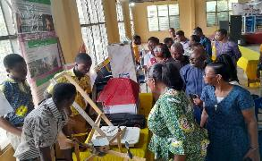
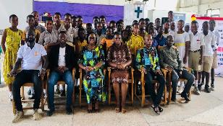

Energy commission senior high schools’ renewable energy challenge 2024-(5th Edition)
The Senior High School Renewable Energy Challenge was initiated by the Energy Commission in collaboration with Ghana Education Service with the aim of fostering an interest in renewable energy in students of second-cycle institutions. The challenge seeks to provide education and awareness, promote research and innovation in renewable energy, clean energy and energy efficiency among the various senior high and technical schools in the country.
The challenge was also meant to highlight innovative renewable energy and energy efficiency projects by Senior High School students and provides a platform for the exhibition of their projects.
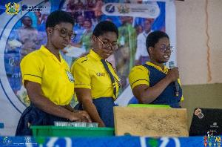
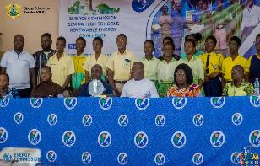
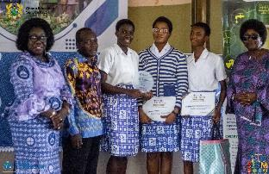
Ten Senior High Schools (Okuapemman School, Aburi Girls SHS, Fodoa Comm. Day SHS, Mamfe Meth. Girls SHS, St. Roses SHS, Oti Boateng SHS, Akwatia Technical Institute, New Juaben SHS, Adonten SHS, Suhum SHTS) in the Eastern Region participated in this year’s competition on the theme; “Application of Renewable Energy Technologies in Solving Land Degradation and Water Pollution”. St Roses’ Senior High School won the day.
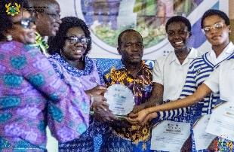

Stem and Entrepreneurship Program in the Eastern Region
The Regional Education Directorate collaborated with M-Hub to organize a free STEM and Entrepreneurship Program for selected Senior High Schools in Koforidua.
M-Hub Technology is an organization committed to bridging the digital divide and fostering technological literacy among Ghana’s youth. As part of our yearly projects, we have an incoming program targeting 42 enthusiastic Senior High School students who are eager to learn about the practical aspects of entrepreneurship, technology, and business operations. These selected students are expected to act as ambassadors and share all the experiences gained with their colleagues back at school
This program was aimed at bridging the gap between classroom learning and real-world success by empowering high school students with essential STEM skills, entrepreneurial know-how, and artisanal craftsmanship. As part of the entrepreneurial talk, participants will visit some business entities in Koforidua.
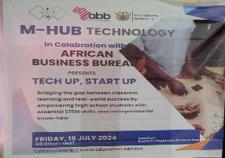
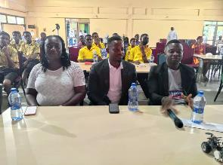
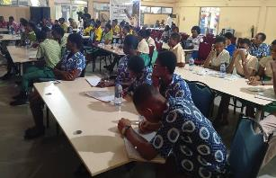

2024 Ghana Girls Start-Up Program
The Regional Education Directorate collaborated with Seeds of Fortune Ghana to organize a free Start-Up Workshop for Girls in selected Senior High Schools in the Eastern Region on the theme “Ghana Start-Up Business Competition” on Saturday, 14th September, 2024 at All Nations University Campus, Koforidua.
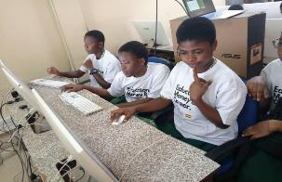
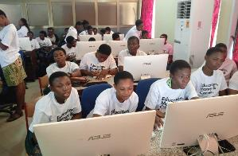
The Girls Start-Up Program is a Business Plan Competition which assists our Senior High School participants in setting up social enterprise business ideas and a professional website that will impact the communities in which they live. Participants are mentored to innovate ideas, pitch their businesses, and receive college prep from our corporate and college partners.
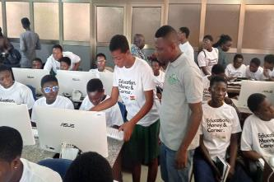
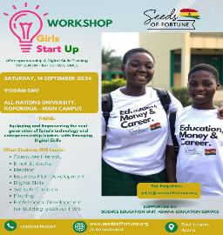

Ghana Digital and Innovation Week 2024
The Digital Transformation for Inclusive Entrepreneurship in Ghana (DTEG) project commissioned by the German Federal Ministry for Economic Cooperation and Development (BMZ) and implemented by the Deutsche Gesellschaft fΰr International Zusammenarbeit (GIZ) GmbH in cooperation with the Ministry of Communication and Digitalisation (MoCD) organized the Ghana Digital and Innovation Week (GDIW) 2024 event in the Koforidua, Eastern Region on 17th September, 2024 at the GNAT Hall, Koforidua.
The theme for the event is: “Innovate Together: Collaborating for Digital Transformation and Impact”.
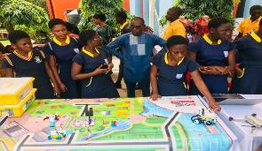
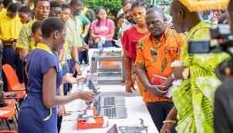
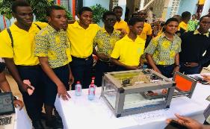
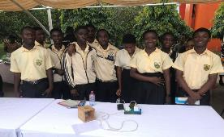
Ghana Science and Tech Explorer Prize (GSTEP) Challenge Outreach Engagement Workshop
The 2025 GSTEP Semi Finalist Induction event took place at GNAT Hall, Koforidua, on Friday,10th January,2025. The finalists were taking through the next phase of the challenge, providing them with the essential insights and collaboration among the teams. Twenty-six (26) successful teams from various municipals/districts in the region qualified for the semi-finals.
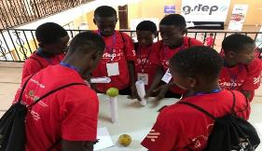
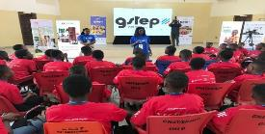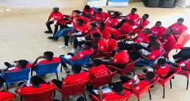


National Maths and Science Quiz (Basic Level) 2024
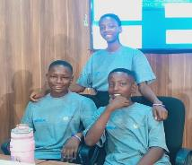
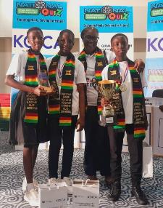
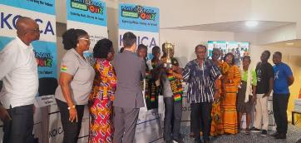
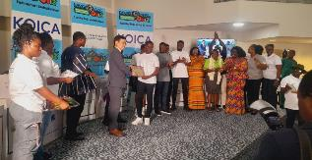
On 5th November 2024, the Abuakwa North Municipality had the honor of representing the Eastern Region at the 2024 National Math and Science Quiz - Basic Level, organized by KOICA in Accra. The region earned its place in the finals by excelling at the zonal level.The final stage featured a fierce competition among the Eastern, Savanna, Northern, and Central Regions. Despite the intense battle, the Eastern Region emerged victorious, winning by an impressive 88pts, followed by Central 75pts, Northern 63 and Savanna 45pts.

Eastern SHS Climate Change Debate
The SHS Climate Change Debate 2024, was held on Tuesday 12th November, 2024 at Oyoko Methodist SHS with St Peter’s Senior High School emerging as winners. A huge congratulations to all 20 participating schools for their dedication, passion, and insights into climate change solutions. Four schools qualified for the finals and delivered an outstanding performance.
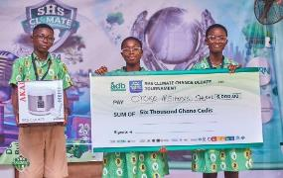
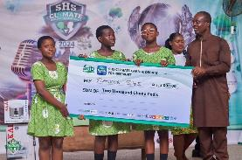
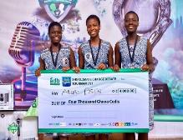
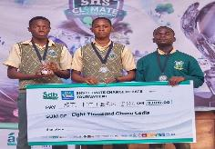
All the four finalists’ schools received cash prizes and medals, and the first to third positions had electrical appliances. Oyoko Methodist SHS placed second, Aburi Presby SHTS third and Saviour SHS was fourth. The SHS Climate Change Debate will be held in the Central Region next year.
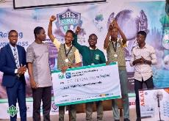
Familiarization Tour by The Director-General of Ghana Education Service to The Eastern Region
On Monday, 4th March,2024, the Director-General of Ghana Education Service Dr Eric Nkansah began a two-day working visit to the region. He was accompanied by the Deputy Director-General in charge of Management Services, Mr. Stephen Kwaku Owusu and a team from T-TEL. Under the able leadership of the Eastern Regional Director of Education, Mrs. Ivy Asantewa Owusu, the team was warmly welcomed and first held an open forum with the staff of the Regional Education Directorate and other key stakeholders in the education fraternity as well as the Eastern Regional Minister, Hon Seth Kwame Acheampong.
The Open Forum was with the Conference of Director of Education (CODE), Conference of Heads of Assisted Secondary Schools (CHASS), Conference of Managers of Educational Units (COMEU), Conference of Heads of Basic Schools (COHBS), Association of Educational Accountants (AEA), National Association of Domestic Bursars and Matrons (NABDAM), Association Internal Auditors, Association of Suppliers, staff of the Eastern Regional Education Directorate and other staff from both New Juaben North and South Municipals.
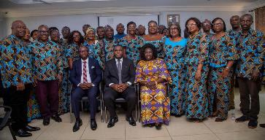
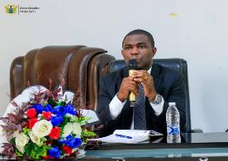
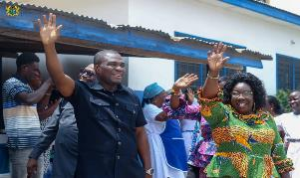
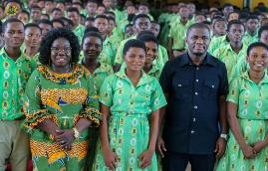
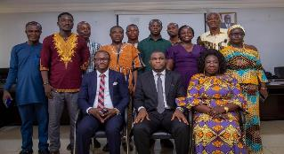
During the second day of the working visit of the Director-General, the team visited some senior high schools and some basic schools within the New Juaben North and South Municipalities, Okere District, and Akuapem North Municipal. The senior high schools visited include Oti Boateng SHS, Oyoko Methodist SHS, Okuapemman SHS, and Mampong School for The Deaf.
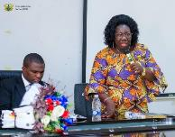
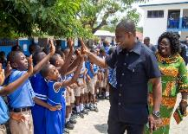
67th National Independence Day Celebration-(Koforidua 2024)
The 67th National Independence Day celebration was held at Youth Resource Centre in the Eastern Regional capital, Koforidua on Wednesday, 6th March, 2024. It was on the theme; “Our Democracy, Our Pride”. The Independence anniversary was officially launched on the 15th February, 2024 at the Centre for National Culture, Koforidua alongside the unveiling of the anniversary logo.
The line-up of activities for the 67th Independence anniversary official started on Wednesday, 28th February,2024 with the ‘28th February Christianborg Crossroads Shooting Incident’ at Freedom Monument-Osu-Accra.
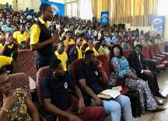
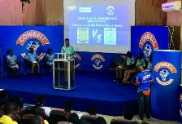
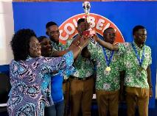
With education, there was the 67th Independence Day Inter Senior High School Debate competition on the 29th February, 2024. The competition took place at the Koforidua Technical University (KTU) Aba Bentil Hall between Sunyani SHS-Sunyani, representing the Northern Zone and St. Hubert Seminary SHS-Kumasi, also representing the Southern Zone. At the end of the contest, St. Hubert Seminary SHS were adjudged winners with 59pts and Sunyani SHS who were the defending champions of the competition had 56pts.

The President’s Independence Day Awards for school children took place at the Accra International Conference Centre (AICC) on 1st March, 2024 and was for children who had performed exceptionally in the Basic Education Certificate Examination (BECE) in the previous year, thus 2023. In all 46 students were awarded, and eight (8) of them were from the Eastern Region.
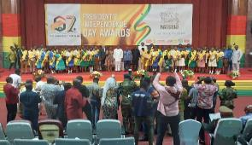
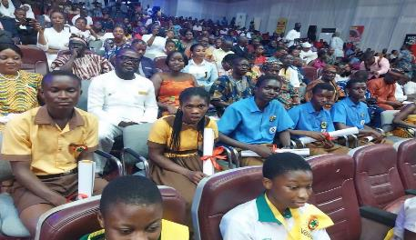
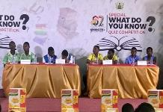
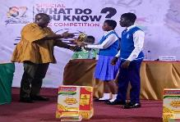
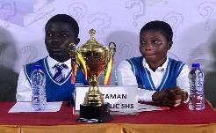
There was also the Special What Do You Know Quiz competition on 3rd March, 2024 at the Koforidua Technical University (KTU) Aba Bentil Hall with the popular quiz master, Mr Dan Afari Yeboah. The competition was between Achiase SHS, Nsutaman Catholic SHS, Damongo SHS and Kintampo SHS. At the end of the competition, it was Nsutaman Catholic SHS who carried the day with 28pts, followed by Achiase SHS with 23pts, Kintampo SHS with 18pts and Damongo SHS with 12pts.
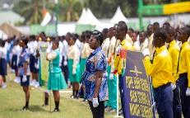
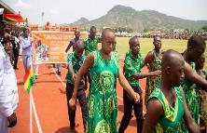
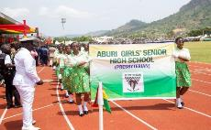
On Wednesday, the 6th of March, 2024, GES contingents that took part in the parade were drawn from selected Second Cycle and First Cycle Schools in the region. They were made up of fourteen (14) Senior High Schools, four (4) basic schools, one Special Needs School, and one Technical School from Ghana TVET Services.

SCHOOL HEALTH EDUCATION PROGRAMME (SHEP)
Report On Leopard Environmental School Clubs Launching at Kyebi Presbyterian College of Education, Kyebi.
The Leopard Environmental School Club was officially launched on 18Th June, 2024 with great enthusiasm, marking a significant step towards fostering environmental awareness and action among students. The event held at Kyebi Presbyterian College of Education auditorium in Kyebi, Eastern Region, Ghana, brought together Eight Hundred (800) students, teachers, community leaders, some governmental and Non-Governmental Organization heads in celebration of environmental stewardship.
This initiative is a key element of the ongoing Okyeman Environmental Foundation Project with the goal of promoting environmental conservation and sustainability as well as reactivating Community and School Environmental Health Clubs in the Okyeman region. This project, will empower young minds in nine selected districts with knowledge and passion for health and environmental conservation. This shared vision recognizes the potential of these young individuals to make lasting impacts on the ecosystem and also marking a significant milestone and commemorating a new chapter of clubs’ activities at the school level.
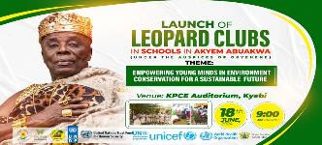
Trainer of Trainees workshop for Municipal/District Officers on Mass Drug Administration
The Eastern Regional Health Directorate and the Ghana Education Service organized a two-day Trainer of Trainees workshop to train District and Municipal officers from the Health and Education Directorates on the pending School and Community Mass Drug Administration (M.D.A). The school Health Unit collaborated with Ghana Health Service to monitor the deworming and bilharzia control programme in the Region. Districts monitored include Atiwa West, Afram Plains North, Afram Plains South Kwahu East and Fanteakwa North Districts. The 2024 School Aged Children Mass Drug Administration was also monitored in the project municipals and districts. Municipals/Districts monitored were Achiase, Asene Manso Akroso, Asuogyaman, Yilo Krobo, Akuapem South, Abuakwa South, West Akim, Afram Plains North and Atiwa East.
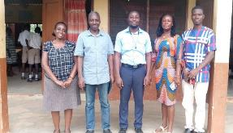
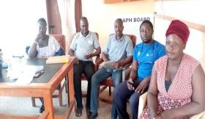
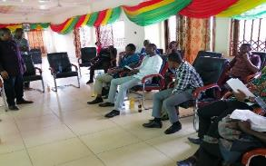
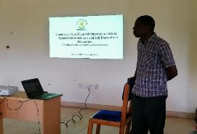

(G-SHPPS) survey
The Global School Health Policies and Practice Survey (G-SHPPS) is an online survey conducted for school authorities.
The purpose of this survey is to provide accurate data on school health policies and practices and also help Countries develop priorities, establish programmes, and advocate for school resources for school health policies and programmes.
The Regional Director of Education, Mrs. Ivy Asantewa Owusu (PhD) warmly welcomed all participants, and encouraged them to take interest in the exercise and also attend to the questions very well and be sincere in answering all the questions in order to give accurate data on school health policies and practices.
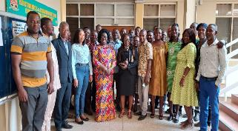
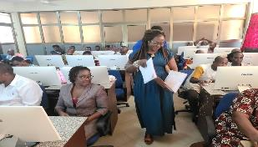
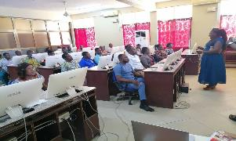
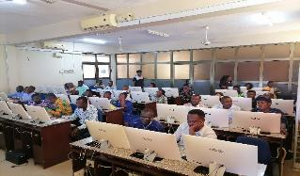
In the Eastern Region, sixty (60) schools were scientifically selected to take part in the Programme and all the expected participants were present and so the Region recorded 100 percent (%) participation.

Basic Education Certificate Examination (BECE) Monitoring
The 2024 Basic Education Certificate Examination (BECE) started on Monday, 8th July, 2024 with 2,118 schools in the Eastern Region. A total of 53,264 candidates comprising of 26,829 males and 26,435 sat for the exams at 195 different examination centers in the region.
The Eastern Regional Director of Education, Mrs. Ivy Asantewa Owusu (PhD) and her team of officers, on Monday, July 8, 2024 went to some exams centers to monitored the conduct of the 2024 BECE. The team went to the Akuapem North, Akuapem South and Nsawam-Adoagyiri Municipals of the Eastern Region. Another team of officers, led by the Deputy Regional Director, Mr. Benjamin Nai, also went to Suhum, Abuakwa South and Atiwa West Districts to monitor the conduct of the exams.
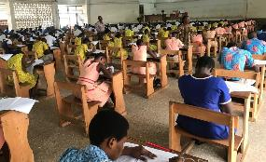
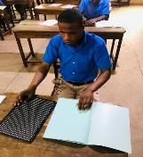
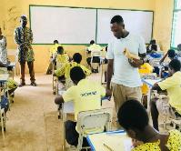
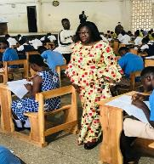
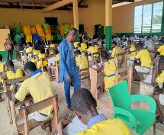
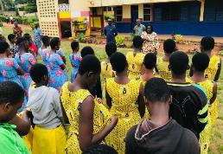
Akroso Senior High Technical School (AKROSTECH)-Bronze Medallists in the 10th African Tug of War Championship
Akroso Senior High Technical School who made Ghana proud at the just ended 10th African TUG of WAR Championship in Victoria Falls, Zimbabwe-2024, on Wednesday,3rd July, 2024 paid a curtesy call on the Eastern Regional Director of Education and the Regional Minister. The team together with the headmistress Mrs. Belinda Twum, trainer and Head of Physical Education Department of the school presented their medals to the Regional Director.
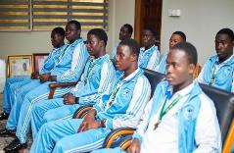
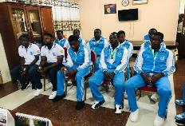
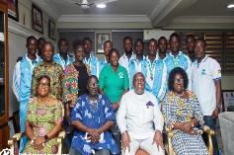
The Regional Director, Mrs Ivy Asantewa Owusu (PhD) and some management members of the Directorate welcomed the team warmly and praised the exceptional performance of the team that has earned the school, the region and Ghana a commendable record in African Tug of war. Akroso Senior High Technical School was the only team from Ghana and competed with twenty-nine (29) teams from four (4) African countries including Ghana. Their outstanding display of strength, teamwork and dedication won them, bronze medal.
Eastern Regional Education Directorate Outstanding Achievement Awards-2024.
The Eastern Regional Education Directorate Outstanding Achievement Awards-2024, held at the Centre for National Culture, Koforidua on Thursday 8th August, 2024. The event which was organized under the theme, “Inspiring Change: Recovery Begins with Teachers” also honored sixty-six (66) non-Teaching lower rank personnel, thus Drivers, Labourers, Artisans and Security personnel in the region. Mr. Terkpertey Michael Tetteh, an Economics teacher at Abuakwa State College in the Abuakwa South Municipal was adjudged the overall winner.
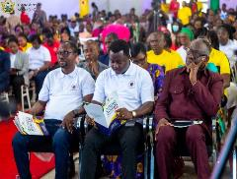
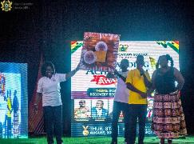
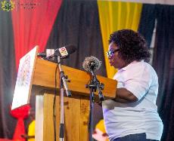
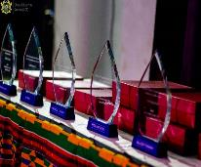
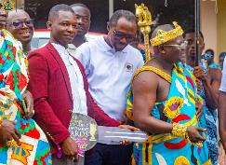

The other categories of the awards include, Teaching; Best Kindergarten (KG)Teacher, Best Primary Teacher, Best JHS Teacher, Best SHS Teacher and Special School. Non-Teaching; Accountants, Matrons/Catering Class, Internal auditors, Logistics and Supply Chain Officers, Administrative and Secretarial Staff. Leadership and Administration; Best Headteacher (Basic), Best Headmaster/Headmistress (SHS), Conference of Managers of Education (COMEU), Conference of Directors of Education (CODE), Regional Education Office and District Education Office staff. Aside these, thirty-five (35) most performing schools in deprived areas were also honoured.

SPORTS
The sports unit organized a series of activities during the year. These included the under 15 soccer completion and inter schools’ games competition among others.
District/Municipal Level Inter School Sports: The following Districts/Municipals were able to organize the First Term sporting activities: Birim Central, Birim South, Birim North, Achiase, Akyemansa, Asene-Manso-Akroso, Kwaebibirem, West Akim, Okere, Ayesuano, Denkyembour, Upper West Akim, Nsawam-Adoagyiri, Akuapem South, Akuapem North, Lower Manya, Abuakwa South, Fanteakwa South, Kwahu East, Kwahu West, Kwahu Afram Plains South and Abuakwa North. A total number of Twenty-Two (22) districts/municipals completed their activities successfully and Eleven (11) are yet to organize their activities.
Regional Level Championship: The Regional Education Directorate organized Inter Collegiate sports for SHS/SHTS Zonal champion schools at Koforidua on 2nd, 3rd, 4th and 8th October, 2024. They competed in Soccer, Handball, Basketball, Netball and Athletics. The program ended successfully.

VISIT OF NATIONAL OVERSIGHT COMMITTEE
The National Secondary Education Reform Oversight Committee of Ghana Education Service, as part of its responsibilities visited the region on Tuesday, 10th December, 2024 and met with the Regional Director, and the Regional Oversight Committee members. The Regional Director and the Regional Oversight Committee members welcomed the team from headquarters, led by Alhassan Liga John (GES-HQ), Clement Osei Antwi (Deputy Director-MOE), and Annabel A Amoako (Secretary-DDG, Q/A).
They further visited some selected Second Cycle Schools within the region. The objective of the school visit is to observe the implementation of Professional Learning Communities (PLC) sessions, assess changes in their lesson delivery particularly for year one students. They gave feedback on the what they observed as part of the implementation of the new curriculum. Among the schools visited were St. Peter’s Senior High School, Kade Senior High-Tech School, St. Roses Senior High School and Boadua Boys Senior High School.

