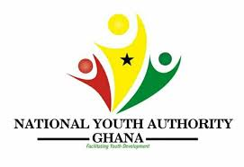


NATIONAL YOUTH AUTHORITY
REPORT ON ACTIVITIES AND PROGRAMS THAT TOOK PLACE IN THE EASTERN REGIONAL SECRETARAIT

- The National Youth Authority as an institution mandated to empower the Youth by inculcating moral and cultural values that will empower the youth in self-actualization, self-reliant and patriotic. As part of the Authority’s plans to promote youth empowerment, the following activities were engaged in the region.

INTERNATIONAL VOLUNTEER’S DAY
- International Volunteer Day is a newly implemented program which will be celebrated across the country every year. This is a celebration that the Staff of National Youth Authority organize cleanup exercises and other forms of work through volunteerism at the various districts, Municipal and communities.
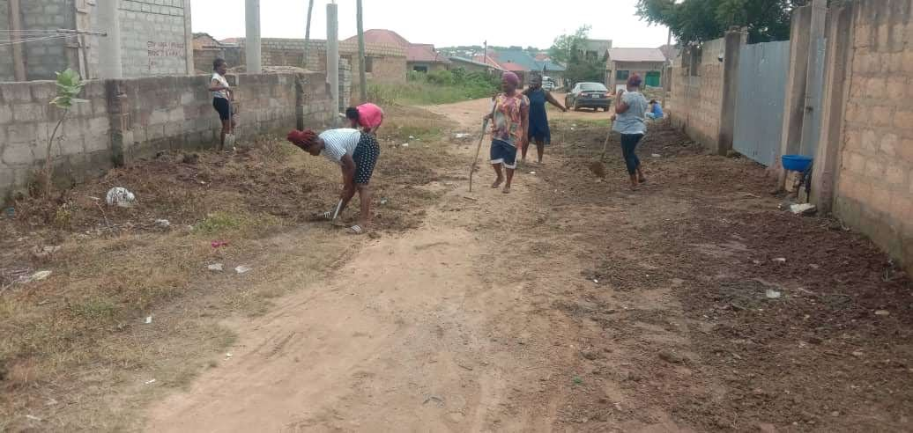

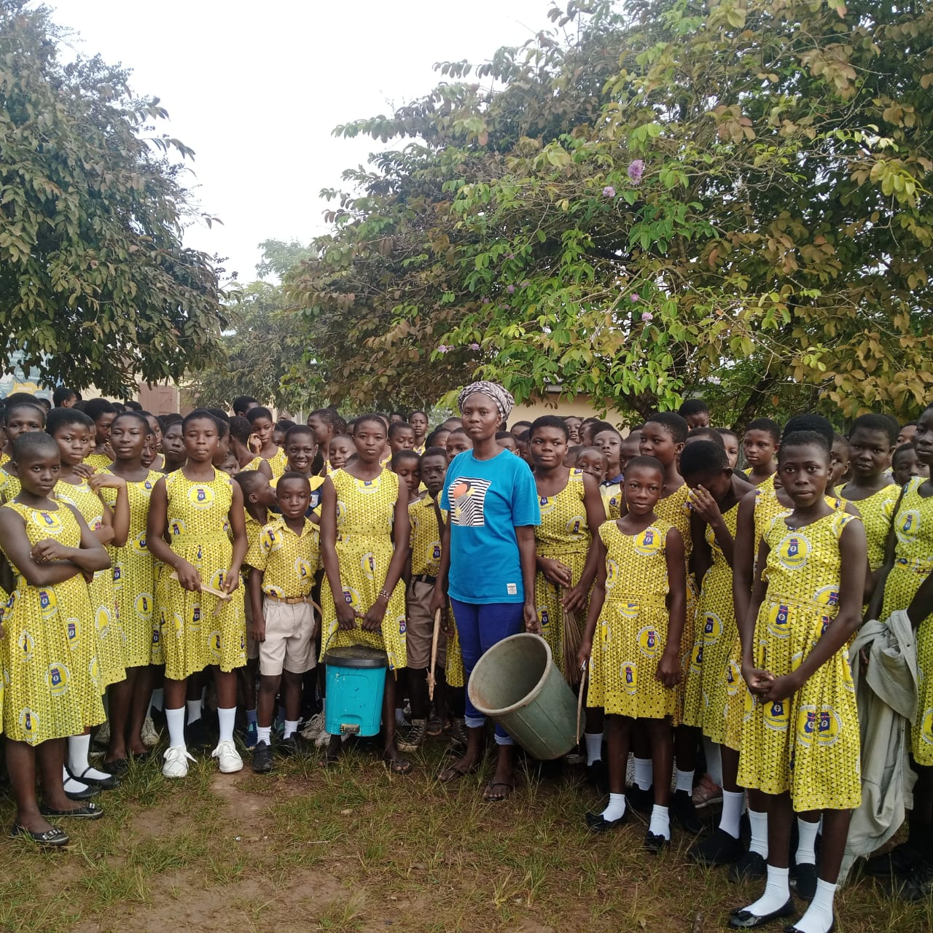

Celebration OF International Youth Day:
The Regional Secretariat of the National Youth Authority collaborated with TECHFARM Hub to commemorate the International Youth Day themed Green Skills for Youth towards sustainable development on 11th August 2023 at Koforidua Technical University (KTU). The Directorate provided about 15 youth led Association and startups who were equipped with resources and technical know-how to enable them use green technology, Skills and processes to gain maximum benefit from the constantly changing world.

Capacity Building Program for Artisans
- The District Director in collaboration with Ghana National Association of Beauticians and dressmaking organized a capacity building for artisans as part of efforts to equip the youth in his district

Catholic National Management Youth Conference
- The Regional Director of the Eastern Secretariat was invited to speak to the Catholic Youth Organization on the theme ‘the role of a crusader during the Catholic National Management Youth Conference. (CYO) In her delivery, she outlined the role of a youth in a society. She added that the Youth are the future leaders of the country hence the need to be good patriots for a better mother Ghana.
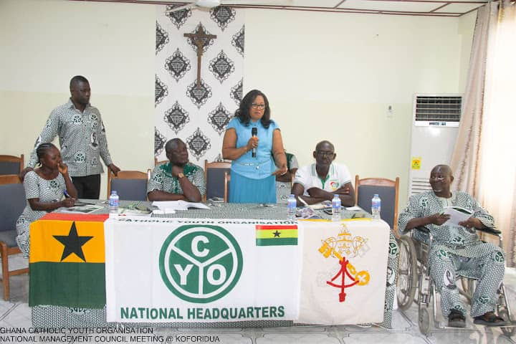

Ghana; the Hunger Project
- The Epic Centre Association in partnership with the Ghana Education service, National Youth Authority and Gender Ministry opened a bakery for Young persons at Boti in the Yilo Krobo District coupled with a ceremony organized for youth who have successfully undergone skill training in dressmaking and hairdressing.

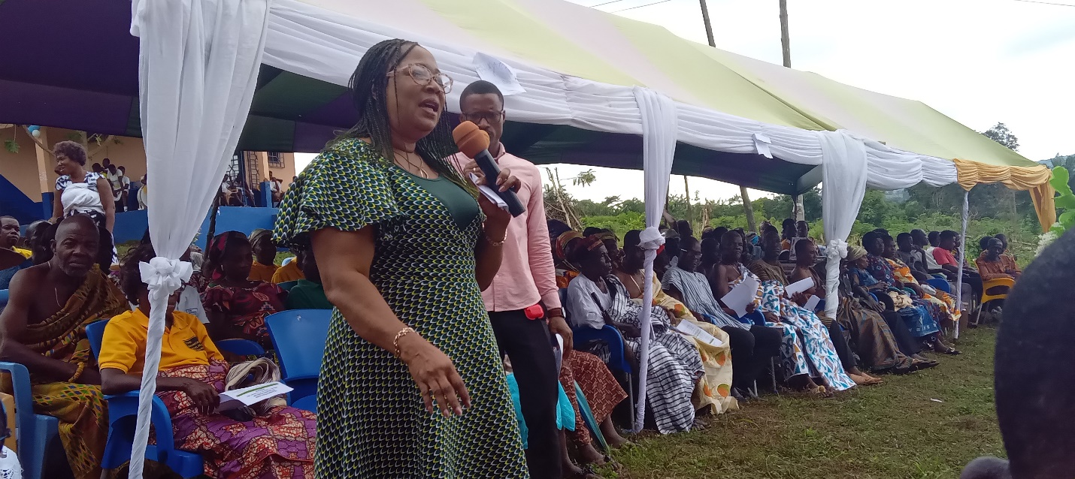
Regional Director, NYA addressing beneficiaries at Boti Epic center

KANEKA Skills Training
- The Eastern Regional secretariat of the Authority in collaboration with a Japanese based company Kaneka organized a workshop for potential and hair stylists in the Eastern region. The workshop was attended by all the various hair stylist association and facilitators. The objective of the training was to inculcate in participants the essence of adapting to trending hair styles, bookkeeping and customer value for money.
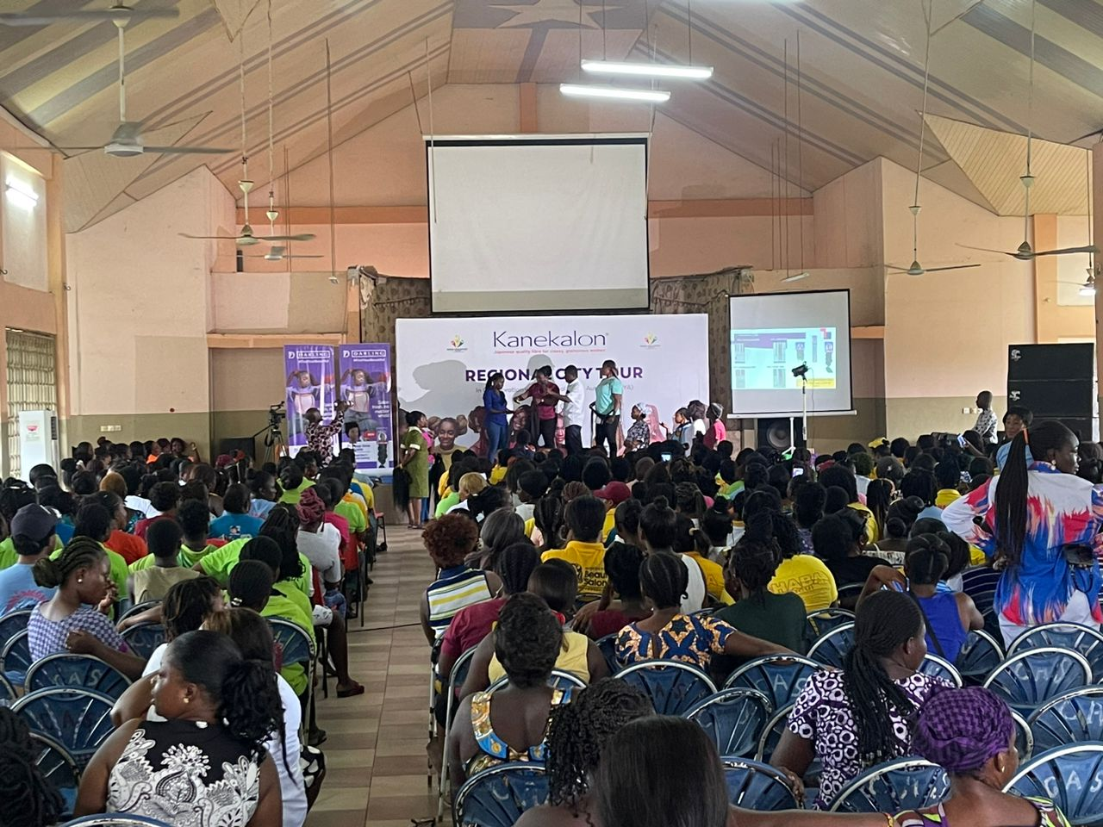
Participants undergoing tutorials’ on trending styles



