REPORT ON ONE –DAY TRAINING PROGRAMME FOR SANIGUARDS
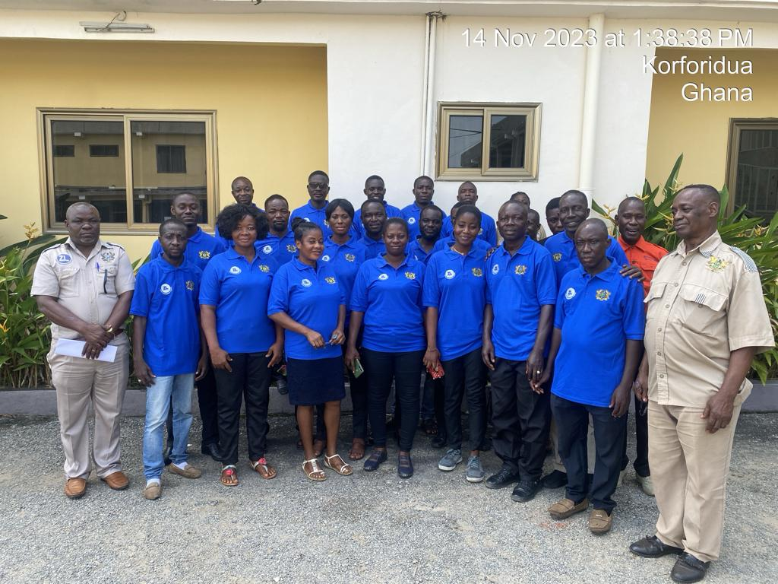
Zoomlion Ghana Limited organized a day workshop for leaders of the Saniguards in the various Municipal/District. All the participants for this particular training were drawn from the 33 Municipal/District Assemblies to Oyinka Hotel, Koforidua on 14th November, 2023.

PURPOSE
The purpose of the training workshop as stated by Mrs. Faustina Shardey, the Regional Manager for Public Service, Zoomlion was to deepening the understanding of Saniguards on their roles and responsibilities, improve their channels of communication and reporting. She also acknowledged that the sanitation guard’s programme are to improve sanitation in communities and help bring change in hygiene behaviour, attitudes and practices among the populace and therefore the need to building their capacity. Further to that, she encouraged the participants to actively participate in sessions.

OPENING SESSION
The Regional Environmental Health Director, Mr. Prince Osei Kissi, welcomed all participants from the 33 districts assemblies. He mentioned that he was happy to see the first Sanitation Training for Saniguards take place organized by Zoomlion Ghana Limited. He expressed that sanitation borders on the health and well-being of people in the region. He therefore, encouraged the participants to actively participate in the training and assured them that he knew that the trainer was experienced in the sector and that they would benefit from him. He further informed them that the knowledge they would get would enable them to make informed decisions and choices on matters relating to sanitation.

FACILITATOR
Mr. Edward Kwabla Shardey

PARTICIPANT AND METHODOLOGY
The workshop was attended by 31 participants specifically, 24 saniguards, 5 officers from zoomlion and 2 officers for the Regional Environmental Health and Sanitation Unit.
The workshop was interactive and included presentations, demonstration and discussion sessions.

TOPICS TREATED:
Participants were taken through topics such as;
Component One
- Inception
- Objective of the saniguard’s programme
- Duties of the sanitation guards
- Role of the team leader
- Channels of communication and reporting
Component Two
- Techniques in Premises Inspection
- Premises entry
- Greetings and courtesy
- Introduction and your mission
- Systematic inspection /monitoring
- Record nuisances & actions taken
Mr. Edward Kwabla Shardey, gave an overview of the inception of saniguard’s programme in Ghana and its roll out in the Eastern region. He also explained in detail the objective of the saniguard’s programme, duties of the sanitation guards and role of the team leaders.
The component two of the workshop introduced participants to Techniques in premises inspection, supporting role of saniguards, Do’s/Don’ts and tasked them to be proactive in their field work.
Participants also demonstrated and enhanced their ability in creating public awareness.

KEY ISSUES
- Delay in salaries payment
- Some EHO/EHAs intimidate saniguards in the field
- The need for a mean of transport to the field
- Inadequate uniforms and boots for field activities
Discussion, clarification and suggestions were given and taken into account by responsible people.

CONCLUSION
On the whole the training workshop was useful. The workshop was closed with remarks by Mr. Prince Osei Kissi. He thanked the organizers Zoomlion and participants for the active participation.

